ALAGAPPA UNIVERSITY
(A State University Re-accredited with “A” Grade by NAAC)
KARAIKUDI

CURRICULUM DEVELOPMENT CELL
AIM & PURPOSE
  - To enrich our existing curriculum to international standards by interacting with subject experts in India and Abroad and involve them in designing and developing curriculum for enhancing the quality of teaching and learning.
  - To offer orientation training to members of boards of studies.
  - To conduct workshops on teaching and research methodologies, curriculum designing and development and employability issues.
  - To prepare teaching modules and text books based on the curricula and syllabi designed and developed by the CDC.

Name | Designation  and Department | status
Dr. C. Yogalakshmi | Professor  Department of Bank Management | Director
Dr. M. Selvam | Co-ordinator  Internal Quality Assurance Cell | Member
Dr. M. Senthil | Professor and Head  Department of Logistics Management | Member
Dr. R. Alamelumangai | Professor  Department of Bank Management | Member
K. Chithra Devi | II- MBA(Banking and Insurance) | Student
M. Ashraf | I- MBA (Banking and Insurance) | Student

Range of Activities(suggested)

1.Offering orientation training to the members of Board of studies of University Departments and Affiliated college
2.Conducting workshops on curriculum designing and developments
3.Organising academic and industry meet for identification of knowledge and skill required for employability in the industrial sector

Activities carried out by the CDC:

1. ACTIVITIES – 2012:
- One week orientation programme sponsored by the UGC was organised for 25 newly recruited Assistant Professors of Alagappa University during 24th – 31st August 2012. 18 eminent professors from diversified disciplines acted as Resource Persons for the programme.
- A meeting on curriculum restructuring organised by TANSCHE Chennai on 29th& 30th October 2012 was attended by The Director of the cell.

2. ACTIVITIES – 2013:
- One day Training Program on ‘Automation of Examination Process’ relating to student’s database management was organised on 17.Sep.2013 by the Curriculum Development Cell in association with Examination Section wherein Principals And Faculty members from affiliated colleges participated.

- Workshop on “ICT cum Innovative Teaching and Research” for the Principals of Affiliated Colleges was organised on 18th April, 2013 wherein Principals of 32 affiliated Colleges and evening Colleges participated.

- One day workshop on ‘Curriculum Designing and Development’ was organised on 24th July 2013 for the Chairpersons of Boards of studies of affiliated colleges wherein 32 chairpersons from various departments of affiliated colleges participated.

- 19 Departments and one constituent college have conducted the meeting of Broad based Board of Studies and revised the syllabi the director of the CDC attended all such meetings.

- Syllabi for seven PG programmes were sent to TANSCHE under Study Abroad Programme on 11th January 2013.

ACTIVITIES - 2014:

- The Curriculum Development Cell has brought out three edited monographs concerning the Orientation Programme and Workshops organised as detailed below:
  - Teaching Strategies for Teachers of Higher Education
  - ICT based innovations in Teaching and Research.
  - Curriculum Designing and Development.
- The CD Cell Printed the revised curricular material for all PG Courses of the Alagappa university departments in two phases (Phase I & Phase II)
- The printed syllabi were distributed to all PG Departments of Alagappa university (I Phase - 10 Departments).

ACTIVITIES - 2015
- The CD Cell Printed the revised curricular material for all PG Courses of the Alagappa university departments under Phase II.
- The printed syllabi were distributed to the 12 PG Departments of Alagappa University.
- Meeting of Board of Studies was conducted in 19 Disciplines during March 2015. The Director of CD Cell participated as one of the member of the Board of Studies meetings.

ACTIVITIES – 2016
- Meeting of board of studies were conducted for 20 PG and M.Phil programmes in the University Departments during 2016. The Director of CD Cell participated as one of the member of the Board of Studies meetings.
- Meeting of board of studies were conducted for 67 UG and PG Programmes for affiliated colleges during 2016. The Director of CD Cell participated as one of the member of the Board of Studies meetings

ACTIVITIES – 2017
- Meeting of board of studies were conducted for 2 PG and M.Phil programmes in the University Departments during up to March 2017. The Director of CD Cell participated as one of the member of the Board of Studies meetings.

Equipments CD Cell for Developing Curricular Materials.
- Book Scanner
- Lenovo Laptop
- Numeric 5KVA UPS System
- Server Software

PHOTOGRAPHS OF ACTIVITIES CARRIED OUT BY CURRICULUM DEVELOPMENT CELL

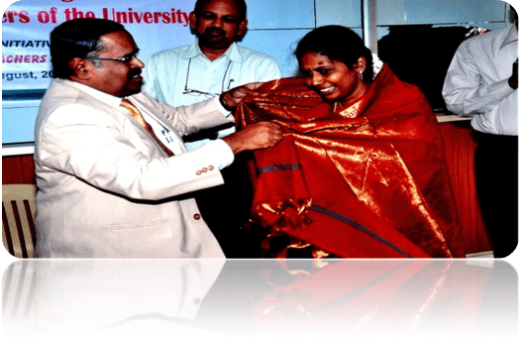
One week orientation Programme on 24th -31st August 2012.

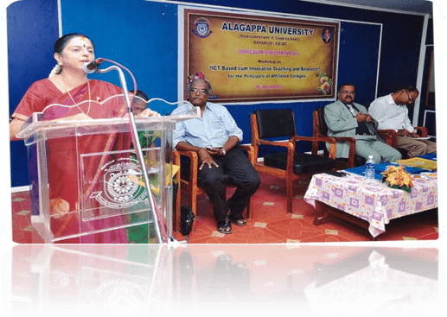
Workshop on “ICT based Innovations in teaching and Research” on 18th April 2013.

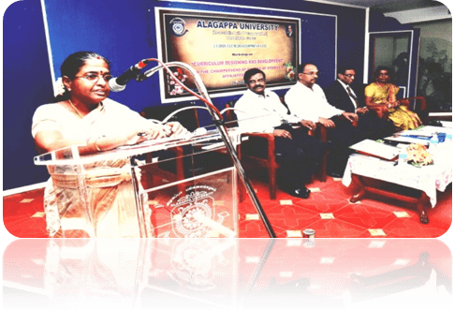
One day workshop on “Curriculum Designing and Development” on 24th July 2013.
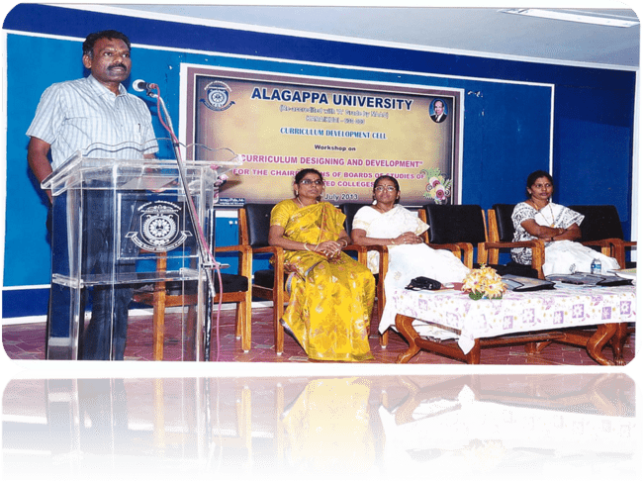One day Training Programme on “Automation of Examination Process” on 17th
September 2013.
**************

