Aim and Purpose  (Suggested) | To create an environment for self-employment and entrepreneurship development through formal and non-formal programmes.
Aim and Purpose  (Suggested) | To motivate and create Business plan/Project plan preparation
Aim and Purpose  (Suggested) | To conduct Entrepreneurship awareness program to the students

Mission
“The educated should become skilled and be self-employed rather than serving under someone; be job creators, rather than job seekers; be innovators rather than meek and blind imitators; and be problem-solvers rather than answer-givers in classrooms and examination halls”.
Name | Designation & Dept./Division/College. | Status
Faculty | Dr. C.K. Muthu Kumaran,Associate Professor, Alagappa Institute of Management | Coordinator
Faculty | Dr. V.A. Anand, Assistant Professor, Department of Logistics Management | Coordinator
Faculty | Dr. G. Ravi, Professor and Head, School of Physics Sciences | Member
Faculty | Dr.K.Chandrasekar,Assistant Professor, Alagappa Institute of Management | Member
Student Representative | R.Matheswaran,MBA,1st year | Member
Student Representative | L.Parthiban, MBA, 1st year | Member

Profile
The Alagappa University University has established the Entrepreneurship Development Cell is located in Management Campus. It is established in 2011 – 2014 with a view to fill the serious gap in our educational system, viz. lack of opportunities for promoting entrepreneurship among the students. The Entrepreneurship Development Cell is focused on creating an inspirational entrepreneurship and innovation culture amongst all segments, especially youngsters, leading to creation and growth of large number of innovative businesses, especially in the manufacturing sector and so on.

Our goal in the EDC is to make it a vibrant nursery-bed for shaping and nurturing successful
Entrepreneurs both in form and content. Entrepreneurs turned out of EDC would go with appropriate entrepreneurial attitudes and values (achievement motivation), besides the skills, attitudes and expertise in their hands.

There will also be facilities for them to re-visit, re-train and get refreshed, as and when the emerging changes warrant. The linkages between the EDC and the new enterprise set-up by our alumni would be reinforcing the benefits for each other.
Objectives
- To create an environment for self-employment and entrepreneurship development through formal and non-formal programmes.
- To create Entrepreneurial culture in the minds of the students
- To train Faculty members to guide & motivate students towards entrepreneurship
- To develop management personnel at appropriate levels for the non-corporate and unorganized sectors like education, rural development, small-scale industry etc.
- To utilize the infrastructure facilities and technically trained manpower for the development of non-corporate and unorganized sectors.

Thrust Activities
- Creating Awareness about Entrepreneurship with different focus for different students.
- Providing Entrepreneurship Development Training for interested students on select product classes with orientation on preparing bankable projects
- Provided exposure to students on Export Business opportunities
- Encourage students to think of small-budget projects with innovative and beneficial ideas.
- Interaction with Successful Entrepreneurs
- Celebrating World Entrepreneurship Day

Main Functions
- Organizing Entrepreneurship Awareness campus, entrepreneurship development programmes and faculty development programmes in the region for the benefit of trainees and trainers.
- Developing and introducing curriculum on entrepreneurship development at various levels including P.G programmes of the university and its affiliated colleges.
- Conducting research work and survey for identifying entrepreneurial opportunities (particularly in S & T areas and service sectors.
- Conducting skill development training programmes leading to self/wage employment.
Activities carried out (Workshops / Training / short-term courses)

S.  No. | Nature of the Event | Date and Venue | No. of participants | Event Outcome
1. | State Level Entrepreneurship Conference  (organized by EDI, Chennai) | 21.12.2012  At Chennai | Three Asst. Professors from Alagappa University participated | Oriented the participants to organize Entrepreneurship training programmes
2. | Regional Industry Seminar on Entrepreneurship - with the collaboration of CECRI, CED-Madurai and EDI-Chennai | 22.01.2013 at Alagappa University | 450 students from the Management, Science and Education disciplines | The significance of technological entrepreneurship and micro, small & medium enterprises were highlighted
3. | 35 Days ‘Technological Entrepreneurship Development Programmes” - in association with the EDI-Chennai and CECRI-Karaikudi | 22.02.2013 to 28.03.2013 at Dept. of Industrial Chemistry, Alagappa University | 27 participants from science and engineering graduates, belonging to Sivaganga, Ramanathapuram, and Pudukottai | The programme mainly focuses on the Electrochemical and Electroplating fields and consists of theoretical & practical sessions on electrochemistry and management inputs.
4. | Certificate course on “Basic Natuvangam in Bharathanatyam | Three months from 15.02.2013 | 20 participants have enrolled for this skill development course. | Special skills on basic natuvangam were imparted to make them employable
5. | Certificate course on “Fashion Knit Garment Tailoring” - in collaboration with Skill Development Centre | Three months from 22.04.2013 | 24 participants have enrolled in this training programme | Special skills on Fashion Garments stitching are being imparted with qualified trainers
6. | Certificate course on “Sewing Machine Operator Training” - in collaboration with Skill Development Centre | 8 weeks on Week-end days from 25.05.2013 | 20 participants are attending this programme | Special skills on Sewing Machine Operation are being imparted with qualified trainers
7. | Certificate course on “Aari work” and “Glass painting” with the collaboration of Centre for Women’s Studies | 13 days from  20th May 2013 to 3rd June 2013 | 30 participants (15 in Aari work and 15 in Glass painting) are attending | Special focus on Aari work and Glass painting are imparted through the professionals.
8. | Industrial Visit to Tiruppur Garment Factory | 2 days  June 2013 | 24 participants | To have firsthand knowledge about fashion garments
9. | Faculty Training Programme | 10 – 14 Sept. 2013 | 30 Faculty members from colleges in Karaikudi area | Training to Faculty members on Entrepreneurship
10. | Certificate Course in “ Beautician Skills” | 13 days – Oct. 2013 | 30 participants | Special skills on Beautician were imparted to make them employable
11. | Faculty Training Programme | 10 – 14 Mar. 2014  Syed Hameedha Arts Science College, Kilakarai | 35 Faculty members from Six affiliated colleges in Ramnad Dist. | Training to Faculty members on Entrepreneurship
12. | Short-term certificate course on “Web-designing, Image Editing & Office Automation Skills” | 15-days  2-16 May 2014  Computer Centre, Alagappa Institute of Management | 28 participants – Diploma, ITI students | Training on Web page creation, Hyperlink creation, Photoshop editing, Multi-layer Image creation, Corel-draw
13. | International Conference on Entrepreneurship & Business Plan Contest | August 2014,  Alagappa University | 340 Participants including Faculty members, Scholars & Students | Invited talks from Industry & International experts. Research papers were presented. Feasible Business plans were rewarded.
14. | Faculty Training Programme | 22nd – 26th Jan. 2015  Alagappa University | 30 Faculty members from Affiliated colleges & Engineering Institutions | Training to Faculty members on Entrepreneurship
15. | Faculty Development Programme in Entrepreneurship | 15-days  12th – 26th Nov. 2015  Alagappa Institute of Management | 35 Faculty members from Univ. departments & Affiliated colleges | Development Training to Faculty members on Entrepreneurship & Small Business Management
16. | Short-term certificate course on “Animation & Graphics Skills” | 16-days  12th – 27th Nov. 2015  Computer Centre, Alagappa Institute of Management | 28 participants Students from Colleges & Polytechnic colleges | Skill training on Graphics, Corel draw, 2D & 3D Animation
17. | National Conference on Entrepreneurial Resurgence and Innovations | One day  19th October 2016  Alagappa University | 450 participants from  Management Departments | Invited talks from Govt Officials and Industry. Research papers were presented. Feasible Business plans were rewarded.

Photographs of Events:

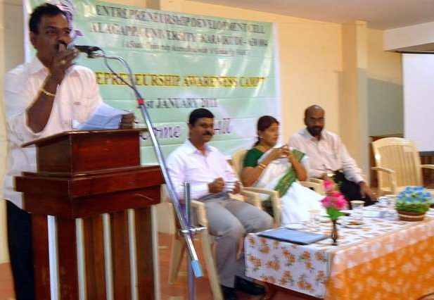
(Shri.E.Srinivasan, SNR Esteem Foods Ltd. addressing in
Entrepreneurship Awareness Camp held on 21.01.2011)

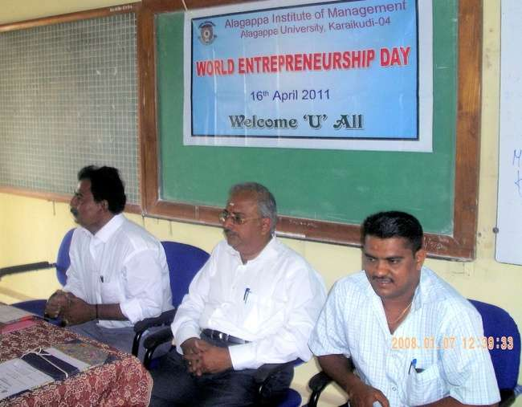
(World Entrepreneurship Day held on 16.04.2011)

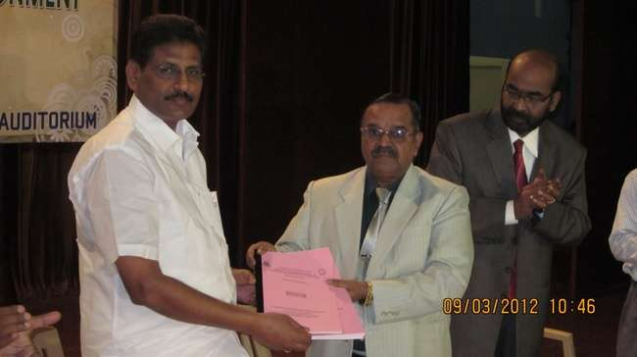
(Shri. KR. Nagarajan, MD, Ramraj Cotton Ltd., releasing the proceedings of
National Conference on Emerging Entrepreneurial & Economic Environment
NCEEEE-2012, 09.03.2012)

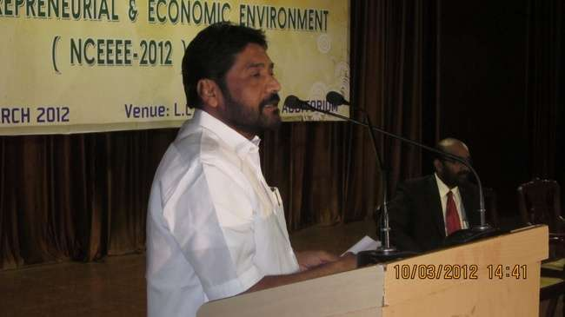
(Shri. A.D.PadmaSingh Isaac, Founder & Chairman, Aachi Masala Foods Pvt. Ltd,
Valedictory speech at National Conference on Emerging Entrepreneurial &
Economic Environment NCEEEE-2012, 10.03.2012)

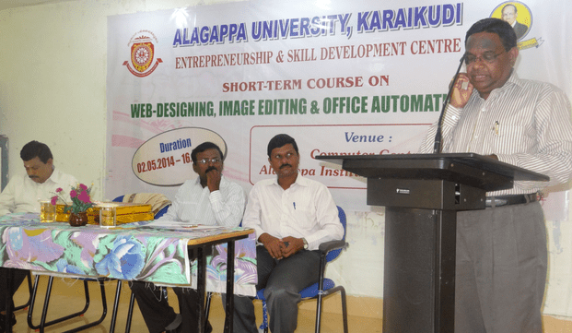
(Dr. H. GurumalleshPrabhu, Special Officer, AU Inaugurating
the “ST Course on Web-designing, Image Editing & Office Automation”
on 02.05.2014)

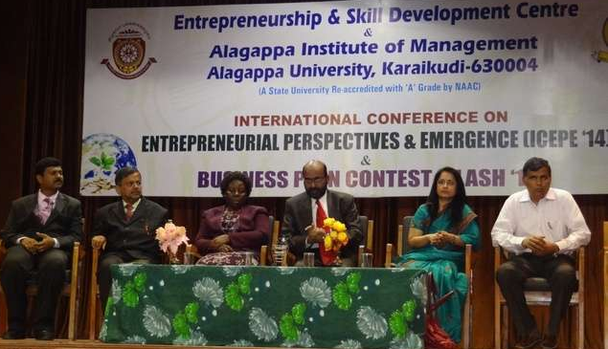
(Inaugural function of International Conference ICEPE ’14 &
Business Plan Contest FLASH ’14 – Guests of Honour – Smt. Rani Muralidharan, MD,
GK Sons Ltd., Trichy, Prof. Dr. R. Sarangapani, IBRA College, Oman &
Prof. Damary Sikalieh, Dean, US Intl. College, Nairobi)

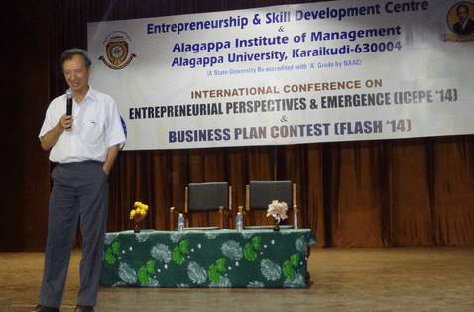
(Prof. Dr. Madoun Mouloud, Univ. of Marseille Aix en Provence, France,
delivering special lecture in the International Conference ICEPE’14 on 8.8.2014)

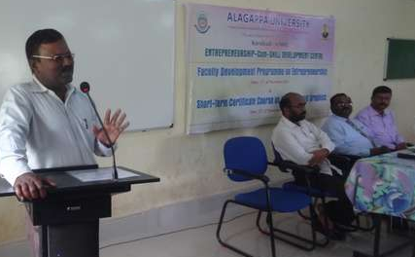
(Inaugural function of FDP on Entrepreneurship &
ST Course on Animation Graphics on 12.11.2015)

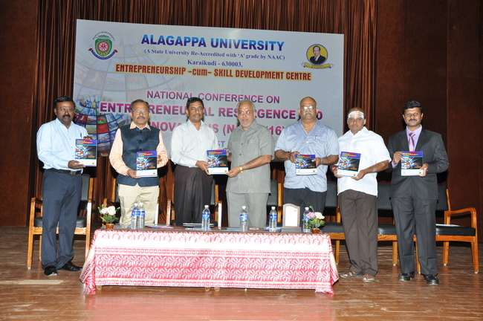

(Inaugural function of National Conference on Entrepreneurship
Resurgence & Innovations on 19.10.2016)

