INDUSTRY AND CONSULTANCY CELL
REPORT

Aim and Purpose
Creation of database and a directory on the faculty wise fields of expertise, infrastructure and consultancy potentials of the University and providing consultancy services of diverse nature as per the demands of the industries. Offering services of testing / material characterization and certification.

Activities | Bringing out brochures, fliers and half yearly newsletters on the ongoing University-Industry collaborations, Industry News, Research Inventions/ Products/ Processes, Newer Expertise and Infrastructure acquired, Training Programmes, etc.,
Activities | Offering Certificate/ Diploma programmes related to Sciences, Applied Sciences, Technology, Management and other professional areas with the duration and credits as per the University norms.  Providing consultancy services of diverse nature as per the demands of the industries.

Name | Designation & Dept./Division/College. | Status
Faculty | Dr.G.Ravi, Professor of Physics | Dean
Faculty | Dr.K.Sankaranarayanan, Professor of Physics | Member
Faculty | Dr.C.Sekar, Professor of Bioelectronics | Member
Faculty | Dr.P.Manisankar, Professor of Industrial Chemistry | Member
Student Representative | Mr.R.Murugan, Department of Physics | Member
Student Representative | Mr.M.Selvamurugan, Dept.of Energy Science | Member

Activities Carried out
Year | Description of Activity | Date | Participants/  Beneficiaries
2014 | University – Industry Interface Meet – I | 28-04-2014 | 60
2014 | University – Industry Interface Meet – II | 7,8-05-2014 | 65
2014 | Industrial visit to EID Parry(India) Ltd., Sivaganga | 05-08-2014 | 5 Professors
2015 | Special lectures from Industry people  i)Dr.V.Vaithianathan, Senior Manager, Worldwide Product support, GT Advanced Technologies, USA/China  ii) Dr.V.Swaminathan, Director, R&D, Akoh WellFit Technologies, Seatown Industrial Centre, Singapore | 07.01.2015 | 70
2015 | MoU has been signed between Alagappa University and Tablets (India) Limited. | 01.07.2015 | Dr.A.Veera Ravi, Dr.S.Karutha Pandian, Dept.of Biotechnology
2015 | Special Lecture on “Opportunities in IIT’s, IISER”  Dr.V.Ramakrishnan, Director, Indian Institute of Science Education and Research (IISER), Thiruvananthapuram | 24.01.2015 | 75
2015 | MoU has been signed between Alagappa University and Himadri Chemicals | 09-09-2015 | Prof.Karuppuchamy, Dept. of Energy Science
2015 | Expert committee meeting to frame common Guidelines and Framework for Collaborations/Consultancy services | 26-10-2015 | 4 Professors including Prof.S.M.Ramasamy, Former Vice-Chancellor, Gandhigram Rural Institute, Gandhigram
2015 | Second meeting to frame common Guidelines and Framework for collaborations/Consultancy services | 09-12-2015  10.30 a.m | 4 Professors including Prof.S.M.Ramasamy, Former Vice-Chancellor, Gandhigram Rural Institute, Gandhigram
2015 | A meeting to review the content of the draft MoU between the Alagappa University and Galaxy Research Technologies (GRT), Karaikudi | 09-12-2015  02.30 p.m | 3 Professors including Prof.S.M.Ramasamy, Former Vice-Chancellor, Gandhigram Rural Institute, Gandhigram
2016 | MoU has been signed between Alagappa University and small scale industry GRT. | 27-01-2016 | 3 Professors including Prof.S.M.Ramasamy, Former Vice-Chancellor, Gandhigram Rural Institute, Gandhigram
2016 | The industry GRT has started its establishing activities in our Alagappa University campus | 03-02-2016
2016 | MoU has been signed between Alagappa University and ITC Ltd. | 29-06-2016 | Dr.C.C.Laxmanan, Chief Scientist, ITC Ltd., The Registrar, Alagappa University
2016 | MoU has been signed between Alagappa University and TCP Ltd. | 29-11-2016 | The General Manager, TCP Ltd and Dr.P.Manisankar, Dept.of Industrial Chemistry
2017 | A special lecture on Non Destructive testes used in Industries Applications | 06-03-2017 | Prof.G.Ravi, Dean Industry & Consultancy, Shri.G.Rajendran, Sr.Dy.Manager, BHEL, Dr.M.Ashok and 120 Participants

MoU signed between Industry and Alagappa University - Department wise
Department of Physics:
A Memorandum of Understanding (MoU) has been signed between Alagappa University, Karaikudi and Galaxy Research Technologies (GRT), Karaikudi, a start-up company in the field of polymer based hollow fibre membrane. Under this agreement, GRT will establish their R&D unit inside the campus of Alagappa University and share the human resources and expertise for developing advanced fibre-fabrication technology which will cater the big demand existing in the field of purification, filtration and waste management.

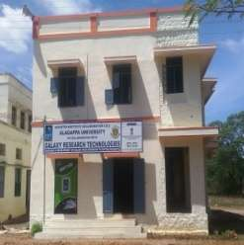 | 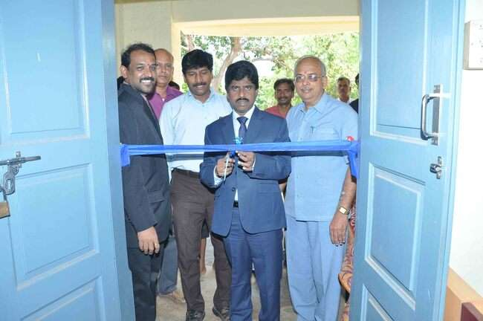
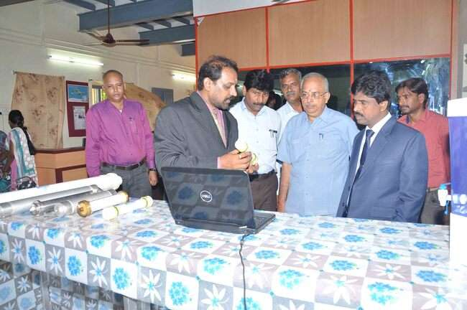 | 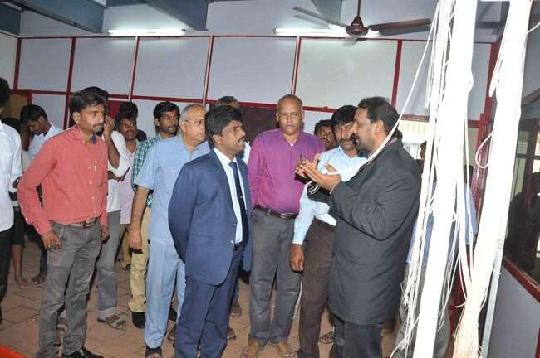

The main objective of the MoU is to provide a forum where the industry and academicians meet together in the campus to share their expertise and to promote their findings into commercial venture. Further this new initiative will facilitate the student community to carry out their projects in the company background and to enhance their skill for more employability. “Student Apprentice” in GRT will be promoted to acquire hands on training in the field of hollow fibre membrane. The specific interest of activities of both the institutions would aim at carrying out research projects related to the areas of Physics and Biology. Further, collaborative development of products and techniques harnessing the achievement of basic sciences will also be made by both institutions.
The expertise of GRT in the field of purification, filtration and waste management may be utilized as and when it is required by the Alagappa University. Dr.V.Balachandran, Registrar i/c and Dr.V.Swaminathan, Managing Director, have signed MoU on behalf of Alagappa University and GRT respectively in the presence of Prof.S.Subbaiah, Vice-Chancellor, Alagappa University and Dr.G.Ravi, Dean, Industry and Consultancy.
Department of Bioinformatics:
Department of Bioinformatics primarily focuses on research aspects of discovery and development of novel drug molecules against various life threatening diseases and disorders.
Hands-on Training Workshop provided in the Department of Bio-informatics:
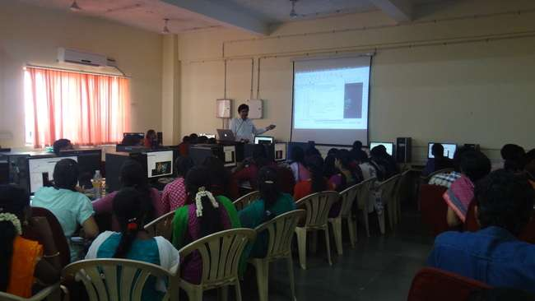 | 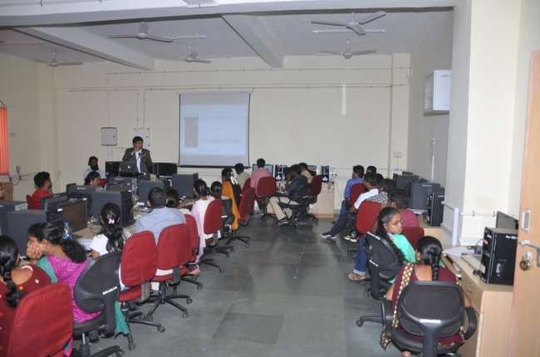
16-19th February, 2016 | 24-27th February, 2015
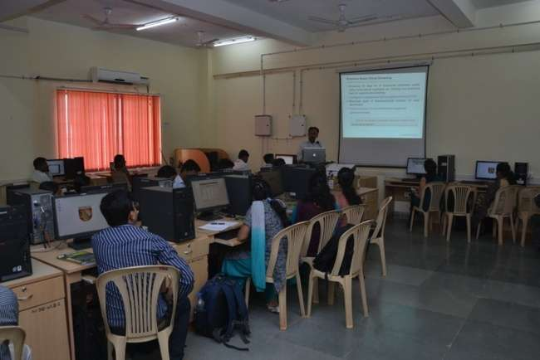 | 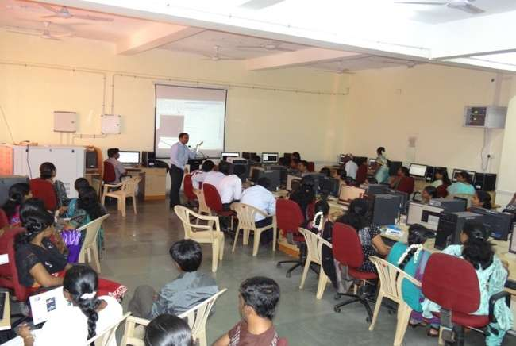
18-21st February, 2014 | 19-22nd February, 2013
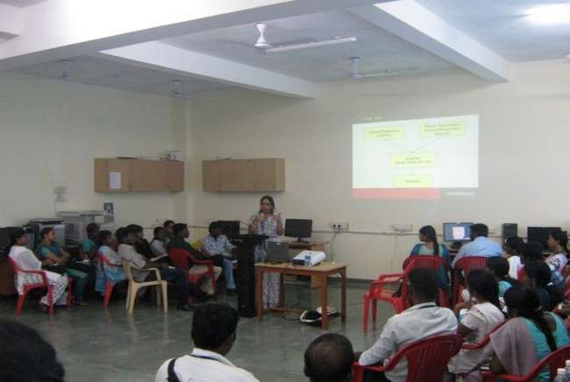 | 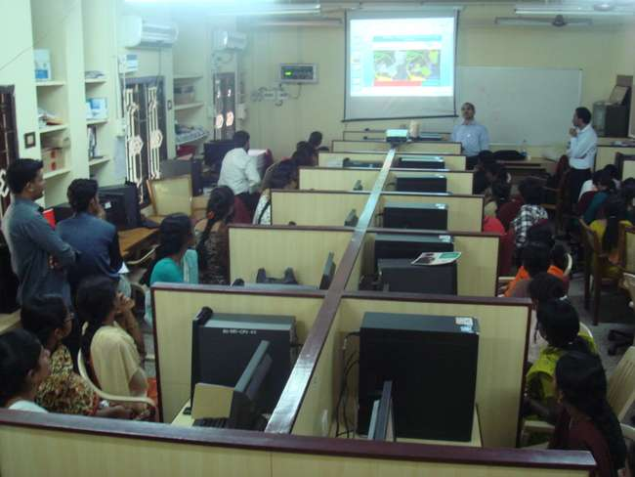
20-23rd February, 2012 | 20-22nd December, 2010

The Department provides a platform in offering consultancy services through numerous Bioinformatics projects. Apart from this, department is actively engaged in training more than hundred students every year from various institutions across the nation through hands on training workshop in the area of Computer Aided Drug Designing (CADD).
Department of Biotechnology:
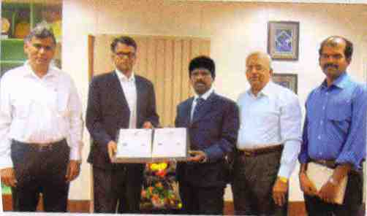
The National institute of Pharmaceutical Education and research (NIPER), Kolkata ,signed A Memorandum Of Understanding(MoU) with Alagappa university,Karaikudi, in the presence of Prof. S.Subbiah ,Vice Challencellor, Alagappa University and Dr.V.Ravichandran , Director ,NIPER-Kolkata.The main objective of this MoU is to establish collaboration for research and academic exchange in “Global Healthcare Research”.The collaboration between the Deparment of Biotechnology , Alagappa Universityand NIPER, Kolkata, will initially concentrate on research activities in the area of active principle testing using the model system. C.elagans available at this department. NIPER , an autonomous body set of under the aegis of department of Pharmaceuticals, Government of india, is known for promoting academic excellence and research in the areas of Pharmaceuticals and consumer healthcare products for the past few years. In order to meet out the future expectations biotech-based Pharmaceutical industries, this MoU will provide a platform for getting collaborative research projects from the funding agencies.

This agreement is expected to promote joint research activities within fields of interest, like testing of novel active Pharmaceutical ingredient in animal models and Pharmaceutical studies in micro platforms, cocenpt for bio mimetic assay development and characterization. Through this agreement, both the institutions can host students and staff of the other institutions as part of jointly laid out academic and / or research collaboration which could lead to joint publications leading international journals. This association with NIPER will ensure Alagappa University researching its goal of achieving excellence in the modern and emerging fields such as personalized medicine. Prof. V. Balachandran, Registrar i/c. and professors from the Department of Biotechnology, Dr.S. Karutha Pandian and Dr. Balamurugan were also present when the MoU was signed.
Department of Energy Science:
MoU has been signed between Alagappa University and Himadri Chemicals on 9th September 2015 in the Alagappa University campus. An amount received from M/s Himadri Chemicals for consultation in the field of Energy materials is Rs. 66,000/-.
Department of Industrial Chemistry:
A Memorandum of Understanding (MoU) has been signed between Alagappa University, Karaikudi and TCP Limited, Kovilur, Karaikudi. Under this agreement TCP has engaged Alagappa University to provide services in connection with their need to carry out detailed ground water study in and around the industry and Kovilur village. Alagappa University will provide consultancy in the detailed ground water study
Small Industry Day Celebration:
The Small Industry Day was co-organized by Industry and Consultancy cell on 30th August 2016 in Alagappa University, Karaikudi. Prof. S. Subbiah, Vice-Chancellor, Alagappa University, delivered the presidential address. Thiru. A. Padmanathan, General Manager, BHEL, Thirumayam has special guest in this function. Dr.G.Ravi, Dean, Industry and Consultancy cell has delivered felicitation address. Prof. Senthil, SO, Planning and Development, Prof. B. Vaseekaran, Prof. K. Balamurugan, faculty members and research scholars from the University Departments attended the programme.
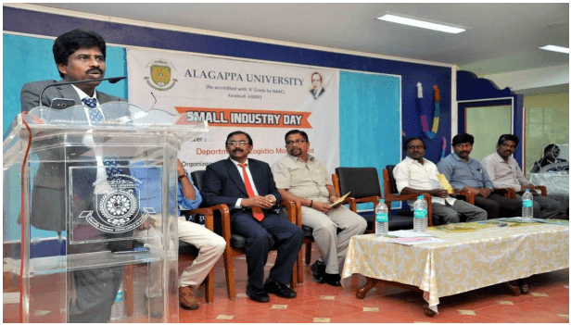 | 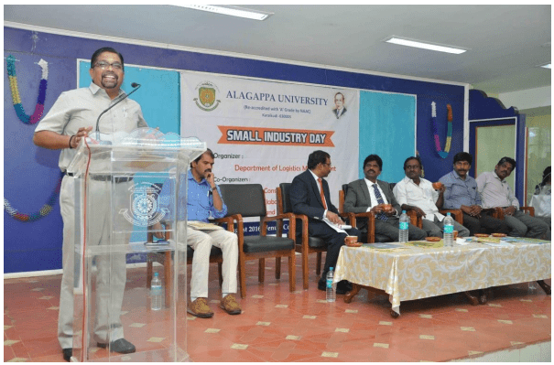
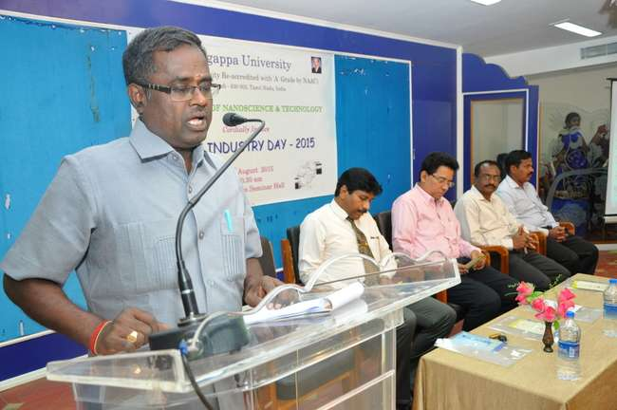 | 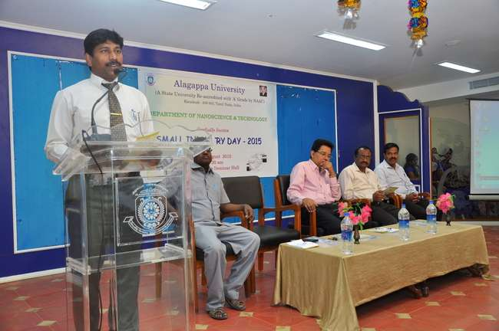

A special lecture on Non Destructive testes used in Industrial Applications
Department of Physics, Alagappa University, Karaikudi has organized a special lecture on Non destructive test (NDT) on 6th March 2017 at 10 a.m. in the Physics Seminar Hall. In this occasion Prof.G.Ravi, Dean, Industry & Consultancy, Alagappa University welcomed the gathering. Prof.C.Sekar, Head, Department of Bioelectronics and Biosensor delivered presidential address in which he has talked about the applications of NDT in industry and in day-today activities. Shri.G.Rajendran, Sr.Dy.Manager, Bharat Heavy electronics Limited, Tirumayam Unit, Tirumayam and Dr.M.Ashok, Associate Professor, National Institute of Technology, Trichy have graced this event with their inaugural addresses. Finally Dr.N.Anandhan, Assistant Professor, Department of Physics has proposed vote of thanks.



