PARA SPORTS CENTRE

Aim and Purpose | To enhance knowledge, understanding and practical application of sports for people with Impairment and disabilities to build their confidence.
Aim and Purpose | To identify the disabled sports persons at the State/National/International Level to upscale their talents.
Aim and Purpose | To impart necessary training to take part in /National/International level of sports events
Aim and Purpose | To facilitate the change of perception and attitude towards persons with impairment
Aim and Purpose | To offer certificate/ Diploma programme in Paralympics and Special Olympics with the academic collaboration of the Tamilnadu Paralympic Sports Association, Chennai/ Paralympic Committee of India
Aim and Purpose | To Create Employment Opportunities

Name | Designation & Dept./Division/College. | Status
Dr.M.Sundar | Principal AUCPE | Director
Dr.K.Murali Rajan | Associate Professor AUCPE | Coordinator
Dr. D. Rajalakshmi | Assistant Profrssor | Member

Range of Activities  (Suggested) | To Conduct Sports event to Special Student at State Level & National Level
Range of Activities  (Suggested) | Organise Seminar and Workshop
Range of Activities  (Suggested) | To Arrange special Camp to Special Student
Range of Activities  (Suggested) | To Arrange Residential Coaching Camp

Activities Carried out
Year | Description of Activity | Date | Participants/  Beneficiaries
2015 | Inauguration of Para Sports Centre Vice Chancellor Prof.S.Subbiah and Thirumathi Apurva I.A.S, Secretary For Higher Education Government of Tamilnadu, Dr.M.Sundar Director, Para Sports Center Dr.K.Murali Rajan Cordinator Parasports centre .Our University Registrar distributed the Prizes during the valedictory function | 6th July 2015 | Dr(Ms) Apoorva IAS Inauguration of Para Sports Centre
2015 | MOU between Alagappa University College Of Physical Education, Alagappa University, Karaikudi, Sivagangai District, Tamilnadu and the Tamilnadu Paralympic Sports Association, Chennai | 6th july 2015 | President Thiru J.Ranjith Kumar TNPSA, Chief Guest
2015 | A meeting was held at Paralympic Sports Centre of Alagappa University College of Physical Education | on 20th July 2015 at 10.30 | Parents Special teachers, Physical Directors, Participants and Volunteers.
2015 | District Sport Meet For Differently Abled,  Alagappa university’s Para sports centre’s athletes participated in the district level differently Abled sports meet at sivagangai open air stadium | 12.10.2015 | Students at School level
2015 | National Seminar On Fit And Healthy India Vice Chancellor Prof.S.Subbiah and Dr.M.Sundar Director, Para Sports Center Dr.K.Murali Rajan Cordinator Para sports centre .Our University Registrar distributed the Prizes during the valedictory function | 29th 30th September | Students of Departments/Centre/ Constituent Colleges of Alagappa University
2015 | Alagappa university Para Sports Centre Organise District Differently Abled Sports & Games on | 7th sep & 12th oct - 2015 | Students from Sivagangai District
2015 | Celebration Of International Day For Disabled Vice Chancellor Prof.S.Subbiah and Dr.M.Sundar Director, Para Sports Center Dr.K.Murali Rajan Cordinator Parasports centre .Our University Registrar Dr.V.Balachandran distributed the Prizes during the valedictory function | 5th December | Students from Sivagangai and Ramanad
2015 | Dwarf Nationals Athletic Championship Thletic Meet Was Held At Bengaluru | 12th & 13th December 2015 | Dwarf National. In This Athletic Meet, Alagappa University Para Sports Team Represented From Tamil Nadu.
2015 | National Para Badminton Championship for the Disabled 2015 Chinnaswamy Stadium – Bengaluru Karnataka. | 29^{h} Dec & 30th Dec 2015 | Student from All Over India Participated
2016 | 16th Senior National Para Badminton Championship  K.L.Mehta Dayanand Public School, Sector-7C, Faridabad. Haryana | 16th – 18th Jan. 2016 | Student from All Over India Participated
2016 | Dwarf National Cricket Tournament held on at MCC Ground Bengaluru, Karnataka | 26th & 27th March 2016 | Student from All Over India Participated
2016 | Swimming State Meet for Differently Able. Theni District on For men and Women | 23rd and 24th July 2016 | Student from All Over India Participated
2016 | District Level Differently Abled Person  Sports Meet -2016-2017  Organised By Sdat – Sivagangai Distract | 15th November 2016 | Student from All Over India Participated
2016 | Celebration Of International Day For Disabled Vice Chancellor Prof.S.Subbiah and Dr.M.Sundar Director, Para Sports Center Dr.K.Murali Rajan Cordinator Parasports centre .Our University Registrar Dr.V.Balachandran distributed the Prizes during the valedictory function | 5th December | Students from Sivagangai
2017 | National level Dwarf Sports & Game s Championship and State level Para Athletic Championship Vice Chancellor Prof.S.Subbiah and Dr.M.Sundar Director, Para Sports Center Dr.K.Murali Rajan Cordinator Parasports centre .Our University Registrar Dr.V.Balachandran distributed the Prizes during the valedictory function | 20th and 21st January 2017 | Student from All Over India Participated
2017 | International Selection Trails at Sonipet Haryana | Date: 07.02.2017 to 08.02.2017 | Student from All Over India Participated
2017 | Exercise ,Training & Diet for High Performance National Level Work Shop . Vice Chancellor Prof.S.Subbiah and Dr.M.Sundar Director, Para Sports Center Dr.K.Murali Rajan Cordinator Parasports centre .Our University Registrar Dr.V.Balachandran distributed the Prizes during the valedictory function AUCPE | 31st Jauary2017 | Student from Other University
2017 | 17th National Badminton  : Hydrabad ( telangana) | 26.02.2017 TO 27.02.2017 | Student from Other State
2017 | State Level Tournament & National Selection YMCA Physical Education college, Chennai Nandanam | 22-02-2017 | Student from Tamil Nadu State

Dr(Mrs) Apoorva IAS Inaugration of Para Sports Centre with Vice Chancellor on 6th July2015
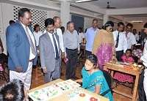

MOU
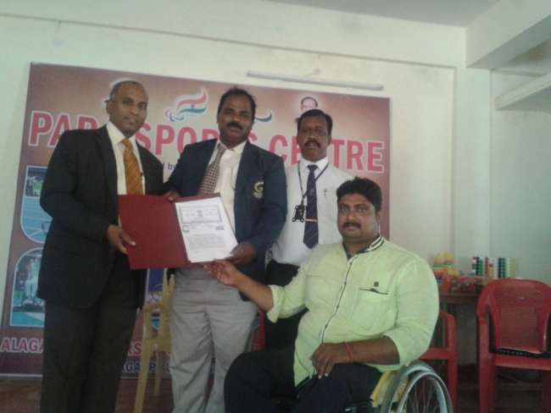

District Sport Meet For Differently

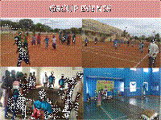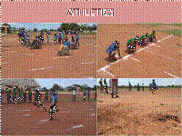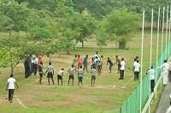

National Seminar

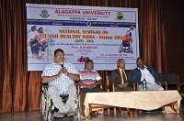

Celebration Of International Day For Disabled

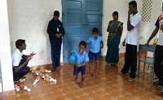

Celebration of International Day For Disabled

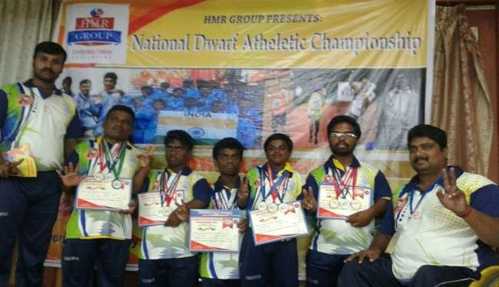

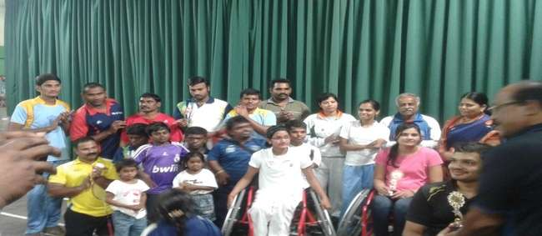

DISTRICT LEVEL DIFFERENTLY ABLED PERSON SPORTS MEET -2016-2017
ORGANISED by SDAT – SIVAGANGAI DISTRACT 15th November 2016

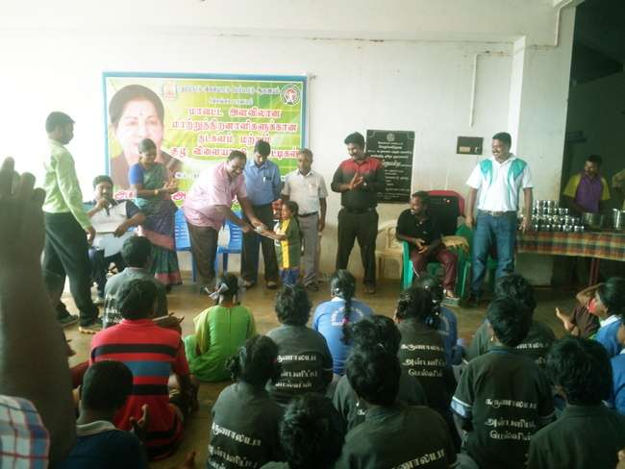 | 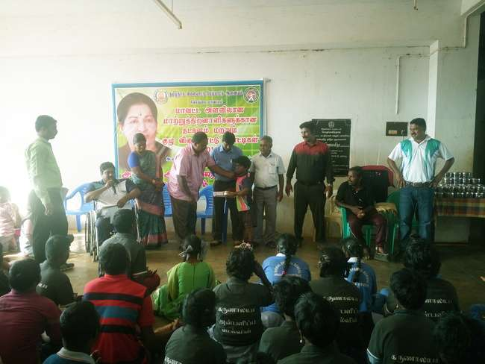

HEARING IMPAIRED KABBADI - WOMEN
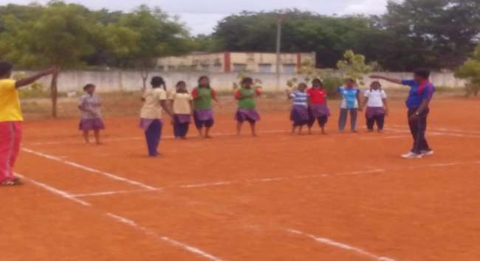
DEAF and DUMB

