UNIVERSITY BUSINESS COLLABORATION CENTRE

Aim and Purpose  (Suggested) | To design and deliver courses that are relevant to current and future business needs (Curriculum Development)
Aim and Purpose  (Suggested) | To provide opportunities for the students to integrate work experience and study (internship)
Aim and Purpose  (Suggested) | To pool research informed leaders of both Universities and Business organization to sustain Word- class research excellence within Universities.
Aim and Purpose  (Suggested) | To create and enterprising and entrepreneurial culture amongst University students and faculty.
Aim and Purpose  (Suggested) | To enable graduates acquire knowledge and skills that are relevant to their future careers and uphold universities as the natural source of the expertise to do so.

Name | Designation & Dept./Division/College. | Status
Prof.B.Vaseeharan | Professor and Head,  Department of Animal Health & Management | Coordinator
Prof.K.Alamelu | Professor,  Department of Bank Management | Member
Dr.J.Vimala | Assistant Professor,  Department of Mathematics | Member
Dr.K.Govindarajan | Assistant Professor,  Department of Education | Member
Miss.A.Iswarya | Research Scholar,  Department of Animal Health & Management | Member
Mr.Mohamed Asras | I Year MBA  Department of Bank Management | Member

Range of Activities  (Suggested) | Training programmes to motivate students to develop entrepreneurial skills
Range of Activities  (Suggested) | Workshop to train the students to acquire business development skills
Range of Activities  (Suggested) | Seminars/Lectures to describe the need for entrepreneurial skill development

Activities Carried out
Year | Description of Activity | Date | Participants/  Beneficiaries
2017 | Two days training programme on “Techniques of Loan appraisal by Banks” | 18th & 19th January 2017 | Students, Research scholars and Faculties.
2017 | Two day “Workshop on Novelty for Sustainability and Dynamic Equilibrium of Business” | 19th & 20th January 2017 | Students, Research scholars and Faculties.
2017 | One day workshop on “International Logistics Leverage (WILL)” | 27th January 2017 | Students, Research scholars and Faculties.
2017 | Two day training programme on “Entrust, Educational and Entrepreneurial Skills of Teacher Trainees (EEETT-2017)” | 30th January 2017 | Students, Research scholars and Faculties.
2017 | Two days National level wokshop and short term training programme on “Micro propagation and Business Commercialization of Indian Medicinal Plant” | 30th and 31st January 2017 | Students, Research scholars and Faculties.
2017 | Two days business training programme on “Textiles and Batteries” | 7th and 8th February 2017 | Students, Research scholars and Faculties.
2017 | Two day workshop on “Fashion and Apparel Accessories Making & Computer Hardware and Networking” | 9th and 10th February 2017 | Students, Research scholars and Faculties.
2017 | Two day workshop on “Computer Hardware and Networking” | 9th and 10th February 2017 | Students, Research scholars and Faculties.
2017 | One day workshop on “Soft Skills- To Meet Industry Need” | 10th February 2017 | Students, Research scholars and Faculties.
2017 | One day training programme on “LATEX- A Mathematical Document Preparation Tool” | 10th February 2017 | Students, Research scholars and Faculties.
2017 | One day awareness programme entitled “Entrepreneurial Approaches in Education” | 13th February 2017 | Students, Research scholars and Faculties.
2017 | Short term training programme on “Training and Scope of SCUBA Diving” | 15th and 16th February 2017 | Students, Research scholars and Faculties.
2017 | Two days workshop on “Career Prospects & Developments in Computer Science” | 27th and 28th February 2017 | Students, Research scholars and Faculties.

Any other

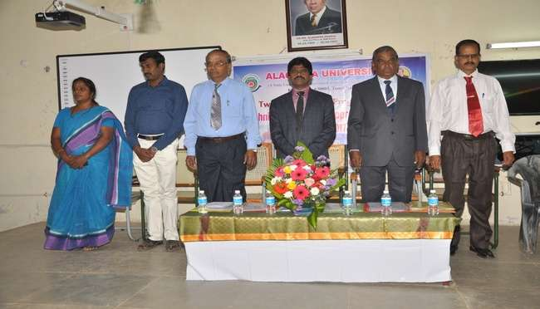
Mr.I.Arun, Credit Manager, Axis Bank, Madurai and Mr.B.Vasu, Senior Executive Manager, City Union Bank, Kumbakonam during the two days training programme on “Techniques of Loan appraisal by Banks” held at the Department of Bank Management on 18th & 19th January 2017.

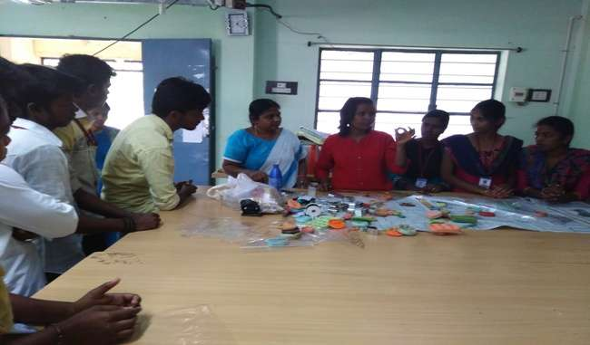
Miss.R.Kalpana, Thurika Kalaikoodam Coimbatore training the students on glass painting and fabric painting during the two days workshop on “Fashion and Apparel Accessories Making” held at Alagappa Institute of Skill Development on 9th and 10th February 2017.

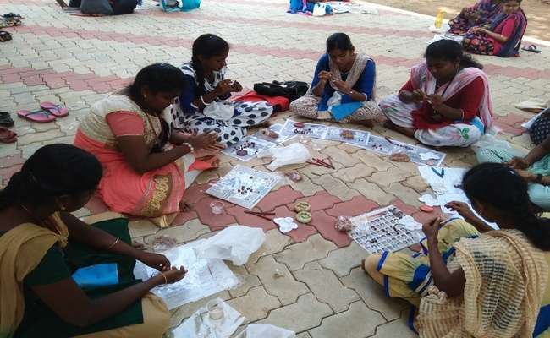
Students executing their practical skills during the two days workshop on “Fashion and Apparel Accessories Making” held at Alagappa Institute of Skill Development on 9th and 10th February 2017.

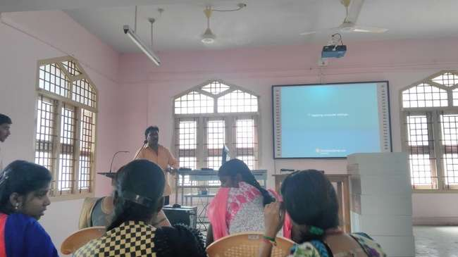
Mr.Saravanan, Director-Networks, ANT Solutions, Madurai explaining the students on hardware components during the two days workshop on “Fashion and Apparel Accessories Making & Computer Hardware and Networking” held at Alagappa Institute of Skill Development on 9th and 10th February 2017.

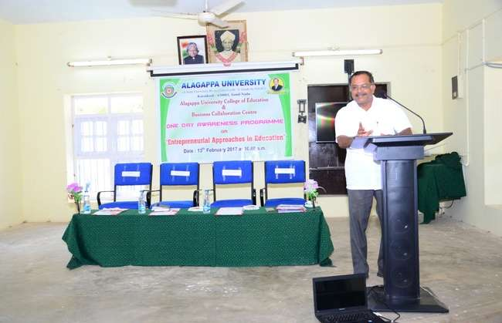
Prof. K.Raja Alias Pranmalai, Director, Centre for Entrepreneurship Development, Gandhigram Rural Institute – Deemed University delivering his talk on “Entrepreneurial Approaches in Education” during the one day awareness programme on “Entrepreneurial Approaches in Education” held on 13th February 2017 at Alagappa University College of Education.

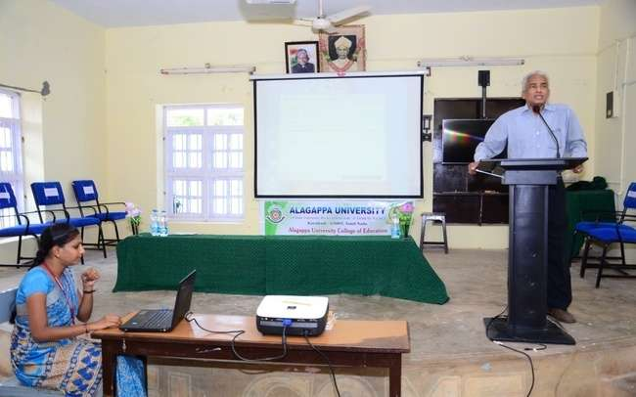
Dr. R. Arangannal, Former General Manager, District Industries Centre, Dindigul, delivering his talk on “Role and functions of DISTRICT INDUSTRIES CENTRE (DIC)” during the one day awareness programme on “Entrepreneurial Approaches in Education” held on 13th February 2017 at Alagappa University College of Education.

